ITD – ITIN Power Apps Training · Student Lab Guide
Lab 02: Connect the Workforce Availability Data
Management Workforce Availability App — wiring up live data
Estimated time | 45–60 minutes
Difficulty | Beginner — no prior Power Apps experience required
Prerequisite | Lab 00 and Lab 01 completed
You will build | A connected data source, a scrollable gallery of records on My Team, and a working record-details screen

Lab Overview
So far your app looks real but has no data behind it. In this lab you will connect “My Team Availability” to the WorkforceAvailability SharePoint list you created in Lab 00, show its records in a scrolling gallery, let a user tap a record to see its details, and add a way to manually refresh the data.

Objectives
- Add the WorkforceAvailability data source to the app.
- Review its columns and data types inside Power Apps Studio.
- Display records in a gallery.
- Select a record and display its details.
- Refresh the data source.
ℹ NOTE
Make sure Lab 00's SharePoint list (WorkforceAvailability) and its five fictitious sample records still exist before you begin — this lab connects to exactly that list.

Power Apps concepts used in this lab
Concept | What it means
Data source | A connection to data outside the app — here, your SharePoint list.
Gallery | A control that repeats a layout once for every record in a data source.
galAvailability.Selected | A formula that returns whichever record the user last tapped in the gallery named galAvailability.
Refresh() | A formula that re-reads the latest data from a data source.

Part A — Add the WorkforceAvailability Data Source
- Open your app in Power Apps Studio if it isn't already open: go to make.powerapps.com → Apps → click “My Team Availability.”
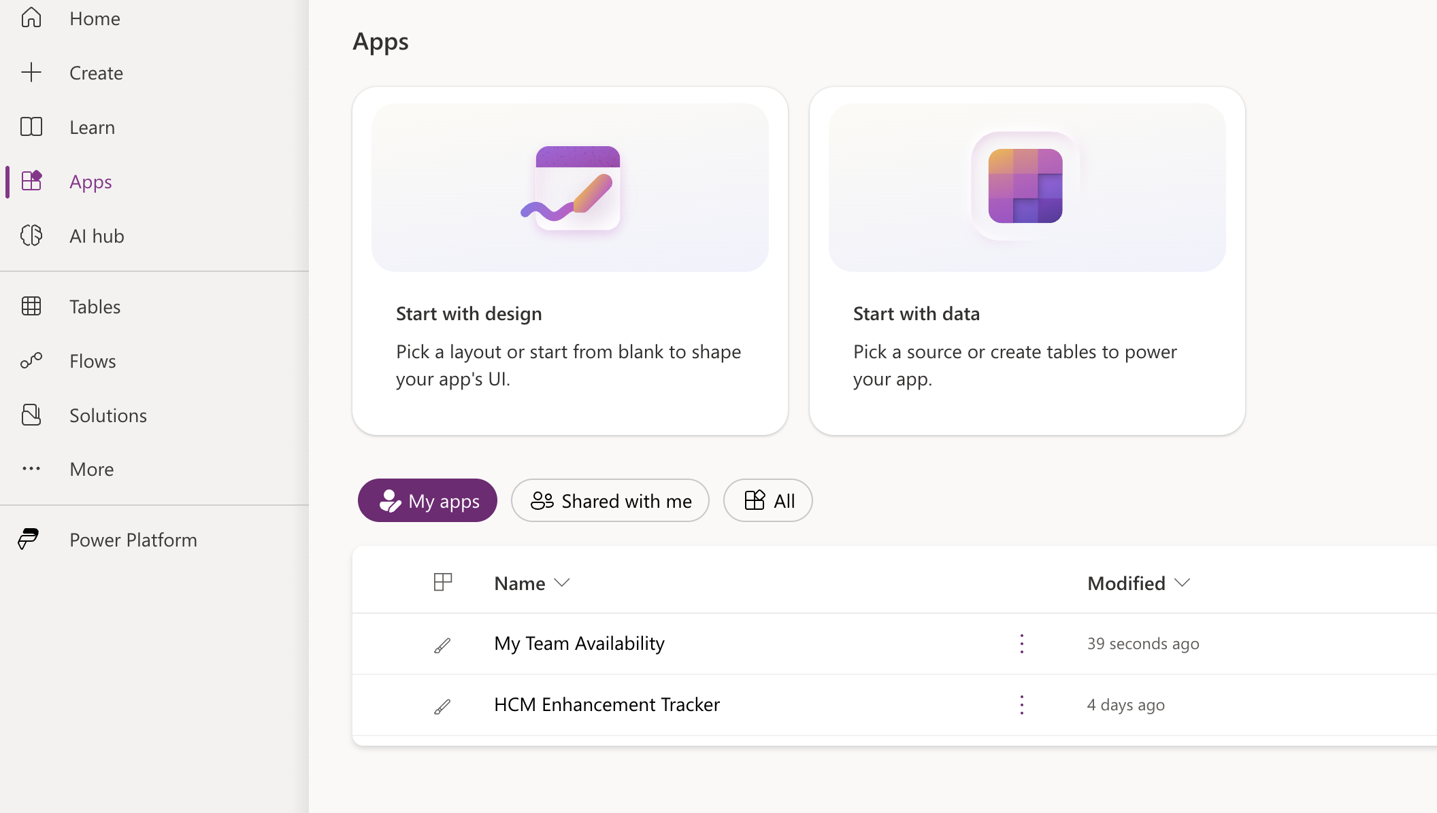
- In the left-hand icon rail (just left of the Tree view), click the Data icon — it looks like a small cylinder/database symbol. This opens the Data pane.
- Click “Add data” near the top of the Data pane.
- In the search box that appears, type
SharePoint
- Click the “SharePoint” connector tile from the search results.
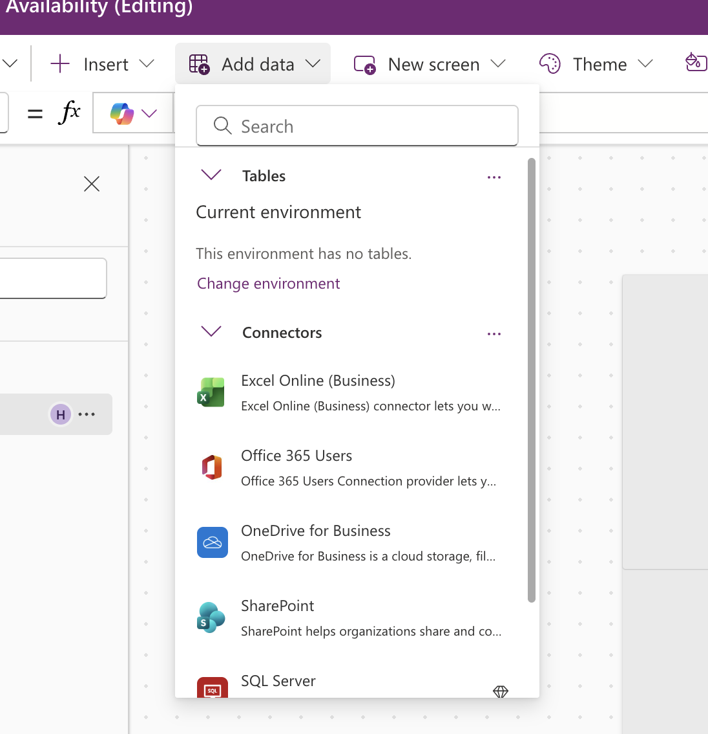
- Choose your training site from the “Recent sites” list, or click “Enter a custom SharePoint site” and paste the site URL you used in Lab 00, then click “Connect.”
- In the “Choose a list” panel, select the checkbox next to WorkforceAvailability, then click “Connect” at the bottom of the panel.
- Confirm the connection — WorkforceAvailability should now be
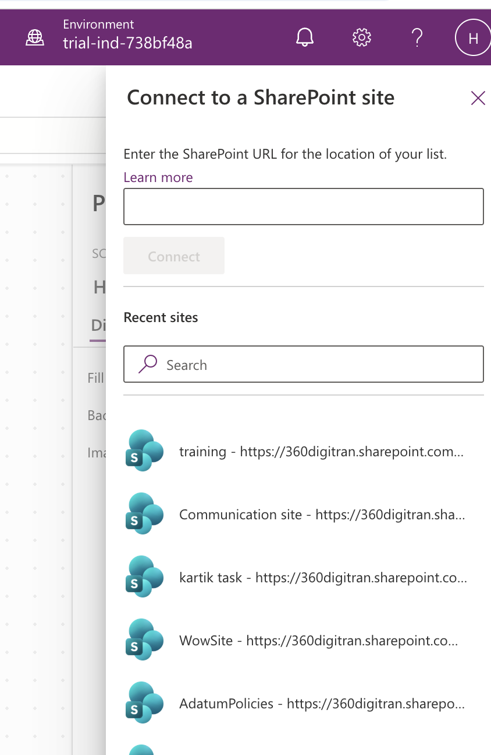
- listed in the Data pane under “In your app.”
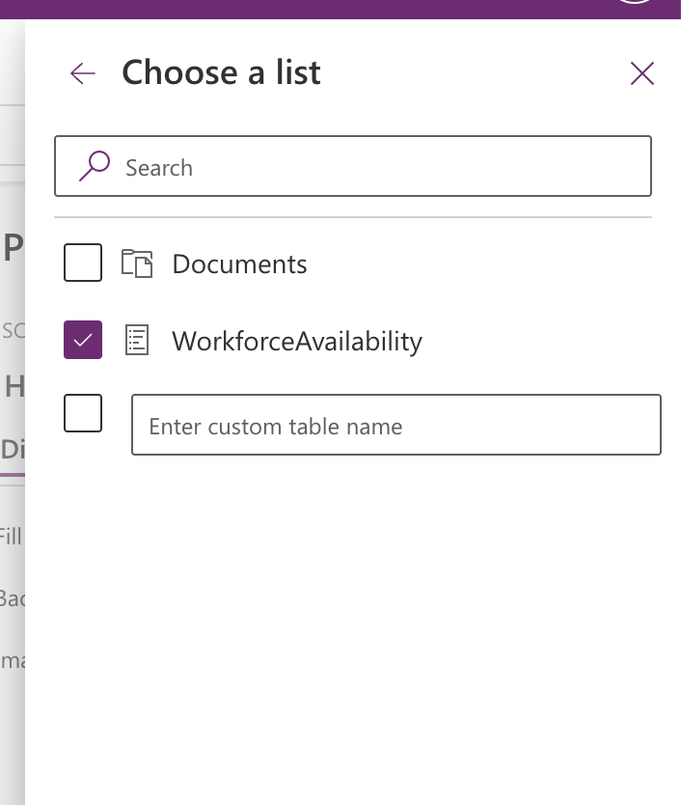
💡 TIP
If you don't see your site in “Recent sites,” you always have the option to type or paste the full site URL instead. Make sure you copy the site address (ending after /sites/YourSiteName), not the address of the list itself.

Part B — Review Columns and Data Types (OPTIONAL)
- In the Data pane, click WorkforceAvailability to expand it and see its full column list.
- Compare this list to the data model table from Lab 00, Part B. You should recognize every column name you created, plus a few SharePoint system columns (such as ID, Created, and Modified) that were added automatically.
ℹ NOTE
Choice columns (like AvailabilityStatus) and Person columns behave a little differently from plain text in formulas — you generally need to add “.Value” at the end, for example AvailabilityStatus.Value. You'll use this in Lab 04 and beyond, so it's worth noticing now.

Part C — Display Records in a Gallery
You will add a scrolling gallery to the My Team screen that lists every availability record. Managers will use this screen in later labs to review their team.

Step 1: Add the gallery
- In the Tree view, click “My Team” to select that screen.
- Click the “Insert” tab on the command bar.
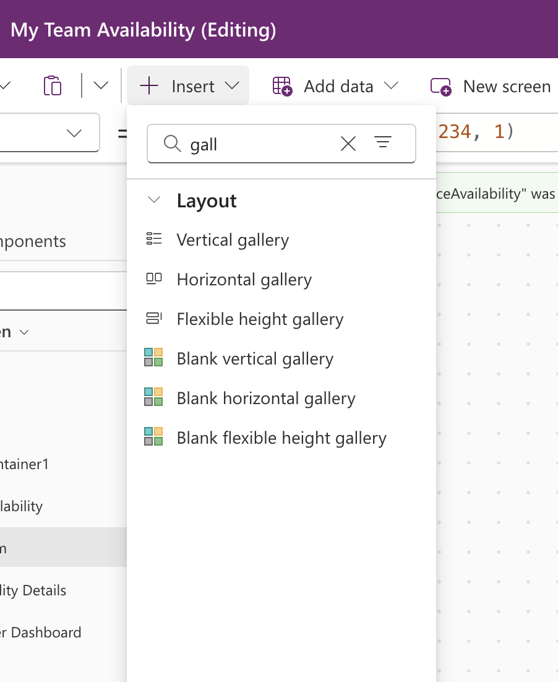
- Click “Gallery” and choose “Vertical” (sometimes shown as “Blank vertical gallery”). A gallery control appears on the canvas.

Step 2: Rename the gallery
- With the gallery selected,
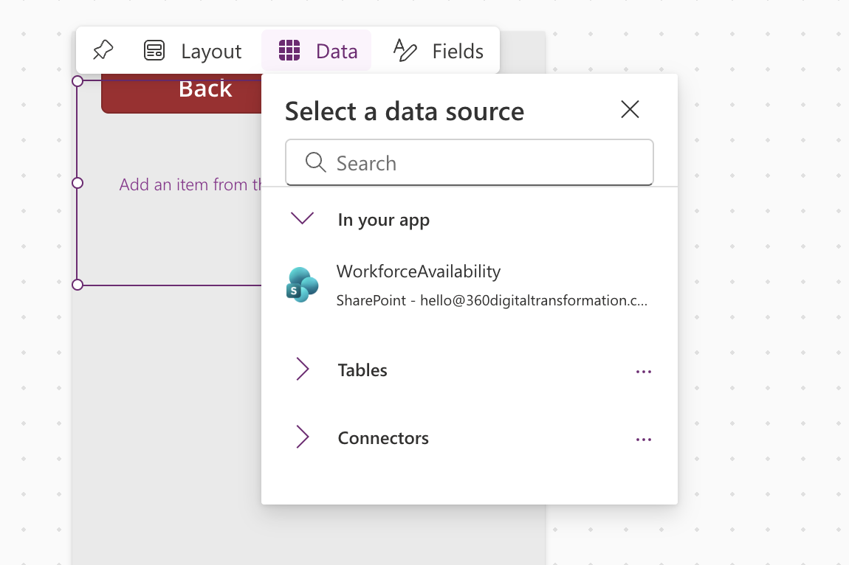
- find the name box at the top-left of the screen, directly above the canvas (it currently shows something like “Gallery1”).
- Click the name box, clear it, type
galAvailability
and press Enter.
💡 TIP
You can also rename any control by right-clicking it in the Tree view and choosing “Rename.” Both methods do the same thing — use whichever is easier to find.

Step 3: Connect the gallery to your data
- With the gallery still selected, find the Properties pane on the right and look for a “Data source” or “Connect to data” option (or, if the gallery already asks “What data would you like to display?” on the canvas, use that prompt directly).
- Choose WorkforceAvailability from the list of connected data sources.
- Confirm the formula bar shows the Items property set to:
WorkforceAvailability

Step 4: Choose which fields display
- With the gallery selected, click “Edit fields” in the Properties pane on the right.
- Click “+ Add field” and add: Title (Employee Name), WorkDate, and ID. Click “Add” after selecting each one.
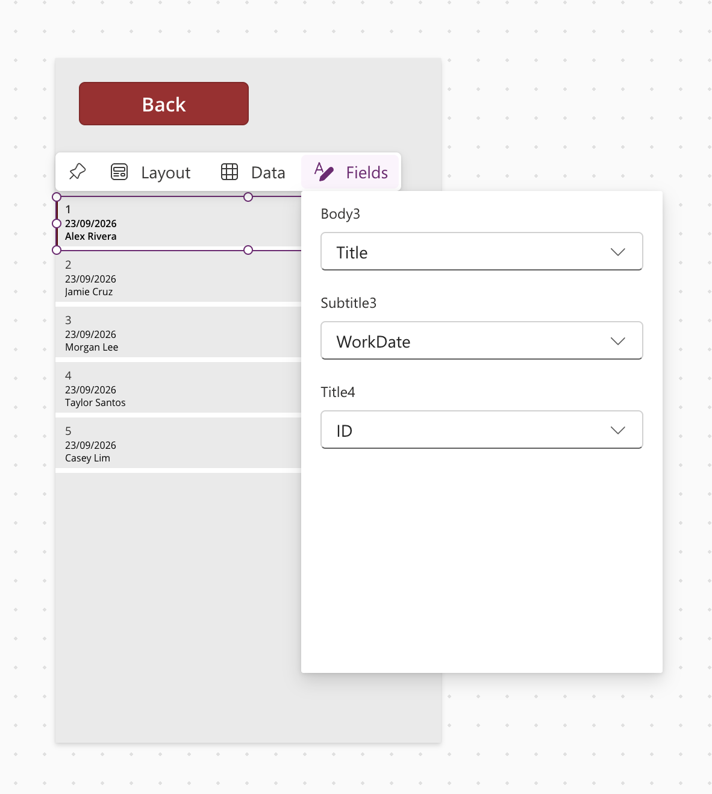
- Close the Edit fields panel and look at the canvas — each row in the gallery should now show these four pieces of information.
✅ CHECKPOINT
Checkpoint: Press the Play button (▶) to preview your app, navigate to My Team, and confirm you see all five fictitious records from Lab 00, each showing employee name, work date, status, and team.

Part D — Select a Record and Show Its Details
Next, wire up the Availability Details screen so that tapping any row in the gallery opens that record's full details.

Step 1: Add labels to the Availability Details screen
- In the Tree view, click “Availability Details.”
- Click the “Insert” tab, then click “Label” to add a text label to the canvas. Repeat this five times, arranging the labels in a vertical list down the screen.
- Select the first label and, in the formula bar, set its Text property to:
galAvailability.Selected.Title
Set the Text property of the remaining four labels to:
- galAvailability.Selected.WorkDate
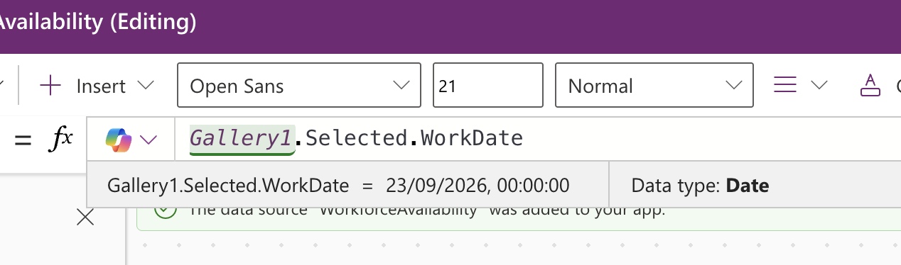
- galAvailability.Selected.AvailabilityStatus.Value
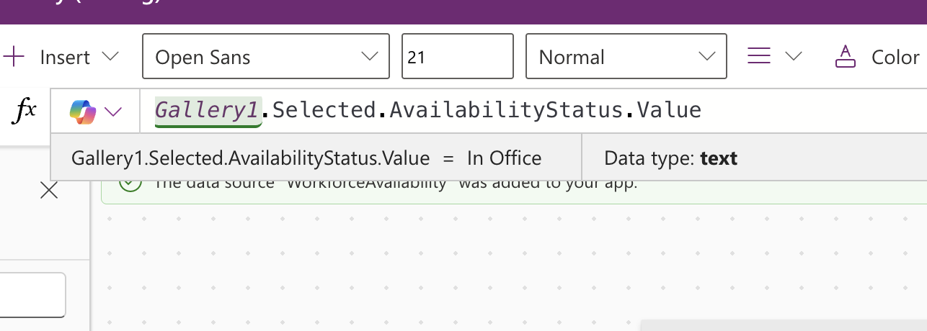

- galAvailability.Selected.TeamOrUnit
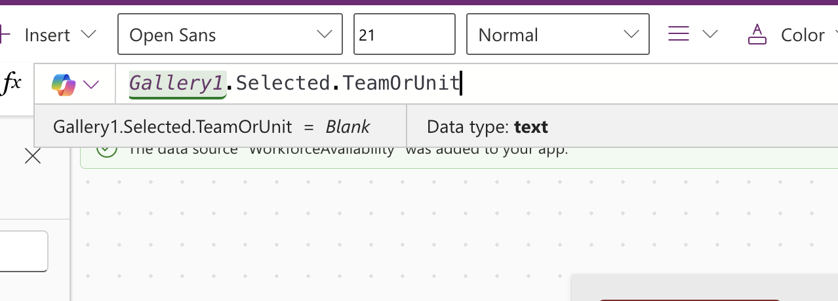
- galAvailability.Selected.CoverageNotes
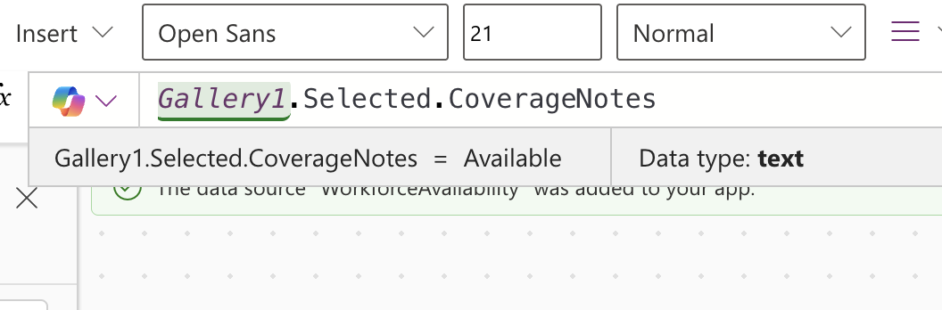
ℹ NOTE
galAvailability.Selected always refers to whichever row was last tapped in the gallery you built in Part C — even though the gallery physically lives on the My Team screen, its Selected property can be read from any screen in the app.

Step 2: Navigate to Availability Details when a row is tapped
- In the Tree view, click “My Team” to return to that screen.
- Select galAvailability in the Tree view (or click directly on the gallery on the canvas).
- In the formula bar, make sure the property dropdown shows “OnSelect,” then type:
Navigate(scrAvailabilityDetails, ScreenTransition.Fade)
- Press Enter to save the formula.
✅ CHECKPOINT
Checkpoint: Preview the app, open My Team, and tap any row. You should land on Availability Details showing that exact record's name, date, status, team, and coverage notes. Tap Back to confirm you return to My Team.

Part E — Refresh the Data Source
SharePoint data doesn't automatically update inside a running app — users need a way to pull the latest changes. Add a simple refresh control to My Team.
- Select the My Team screen.
- Click the “Insert” tab, then “Icons,” and choose the Refresh icon. Drag it to a corner of the screen, above the gallery.
- With the icon selected, set its OnSelect property (formula bar) to:
Refresh(WorkforceAvailability)
💡 TIP
To test this properly: open your SharePoint list in another browser tab, edit one record's status, save it, then switch back to your running app and tap the refresh icon. The gallery should update without you needing to close and reopen the app.

Lab 02 Complete — Checkpoint

Run the App

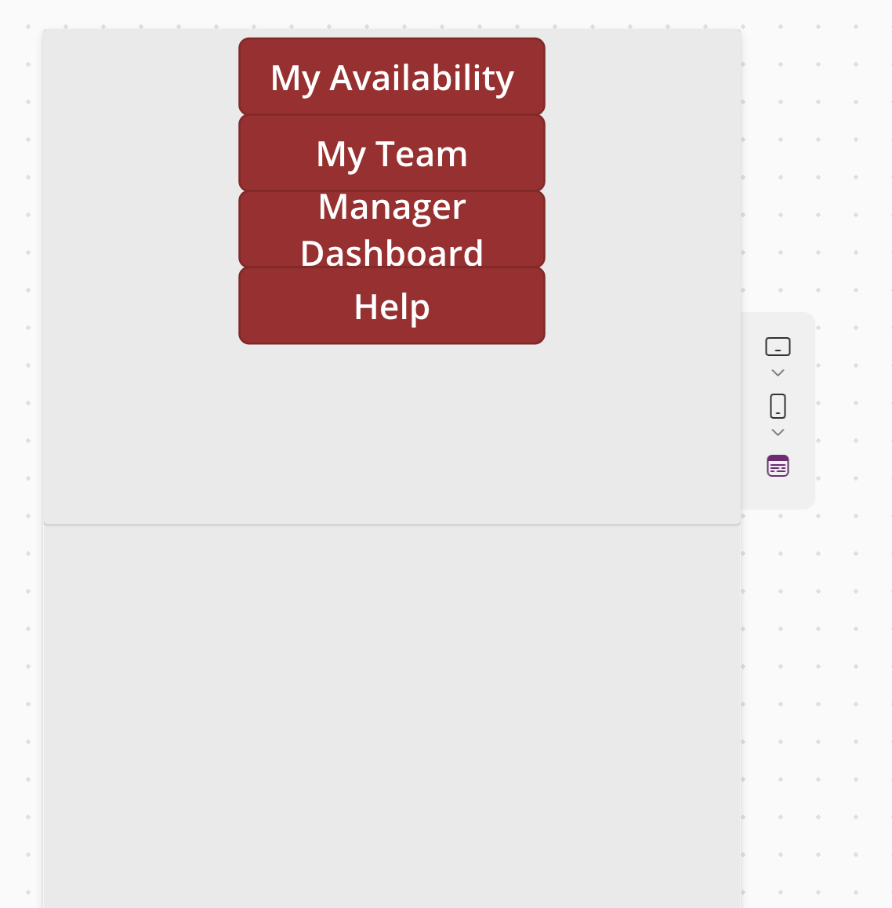

Click on my Team

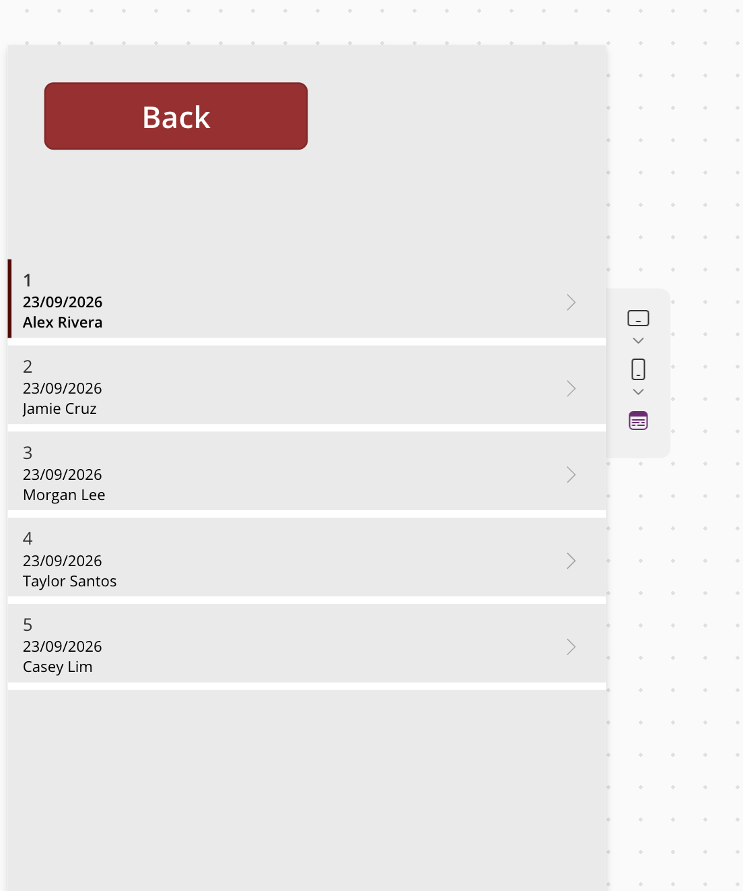

Click on any of the Rows:

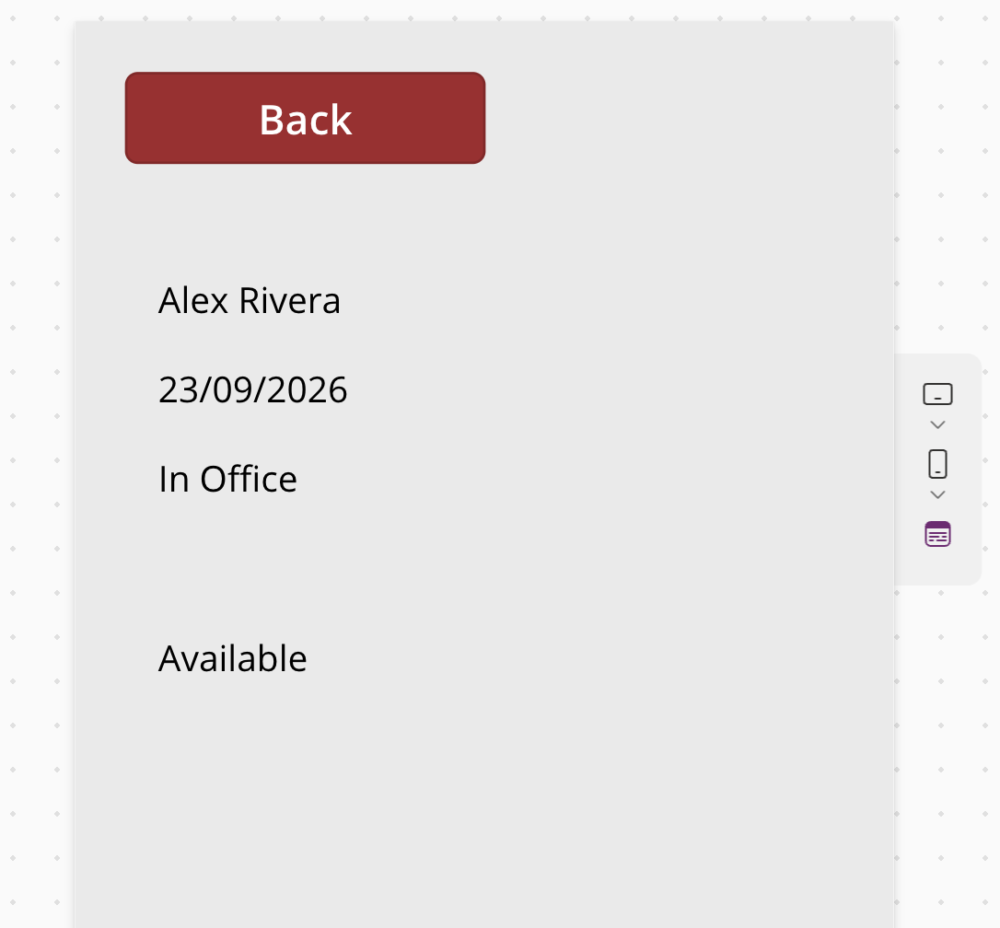
✅ CHECKPOINT
You should now have: WorkforceAvailability connected as a data source, a gallery named galAvailability on My Team showing every record, an Availability Details screen that displays whichever record was tapped, and a working Refresh icon. In Lab 03 you will build a form so users can submit their own availability.

Self-check questions
- What formula displays the record most recently tapped in a gallery named galAvailability?
- Why does AvailabilityStatus need “.Value” added to it in a formula, but Title does not?
- Which formula re-reads the latest data from a connected data source?

Next: Lab 03 — Build the Availability Entry Form

